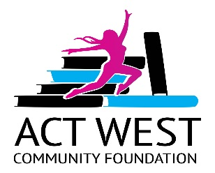
ACT WEST Community Foundation
Application for Education Grant
For single mothers

PART 1
First Name:______________________________________________________________
Last Name: ______________________________________________________________
Home Address:___________________________________________________________
Mailing Address:__________________________________________________________
Email Address: ___________________________________________________________
Phone:__________________________________________________________________
Are you a single mother: ___________________________________________________
How many children do you have and their ages: _________________________________
Explain your current daycare/babysitting arrangements:___________________________

Graduation from high school:
Name of School & location:_________________________________________________
year of graduation:________________________________________________________
(Please provide a copy of your high school completion transcript)
Post-secondary education program you are interested in attending: ________________
_______________________________________________________________________
Are you a Canadian Citizen: Yes / No (please circle the correct answer)

Part 2:
Why are you applying for this funding?
Do you have any financial means of support or sources of income?
If yes, please provide details:
_____________________________________________________________________
If you are selected, you will be required to provide a copy of your Notice of Assessment from CRA for the previous two years to establish income levels.

What are your post-secondary plans for the year 2019-2020: ______________________
When do you expect to complete your program?
What challenges are you dealing with that are preventing you from starting/completing your education program?
How will you manage these challenges while still working on your education?
Please provide a one-page summary of why you are interested in your chosen field of study.
Please also include what it will mean to you if you are chosen as one of the applicants to receive the grant for funding of your education. What will completing your education do to enhance your life?

Personal references:
Please provide two personal references that know you that can attest to your commitment and determination to complete an education program for up to 4 years.

